Supermarket Sales Analysis Using Python
Project Report
Student: Gulam Mahiuddin
AICTE | IBM SkillsBuild Data Analytics with AI Academic Internship Program

1. Executive Summary
This project analyzes 500 supermarket transactions using Python. The workflow includes data validation, KPI calculation, exploratory analysis, trend analysis, visualization and business insight generation.

2. Project Objectives
- Understand dataset structure and data quality.
- Calculate total sales, transactions, quantity sold, average transaction value and average rating.
- Compare city/branch performance.
- Identify high-performing categories and products.
- Analyze monthly sales trends.
- Compare payment methods, customer types and gender groups.
- Validate Sales against Quantity × Unit Price.
- Create reproducible analysis and visualizations.

3. Dataset Description
The supplied workbook contains 500 rows and 13 original columns.
Column | Purpose
Invoice ID | Unique transaction ID
Date | Transaction date
Branch | Branch code
City | City
Customer Type | Customer membership type
Gender | Customer gender
Product | Product name
Category | Product category
Quantity | Units sold
Unit Price | Price per unit
Payment | Payment method
Rating | Customer rating
Sales | Recorded sales

4. Methodology
- Read the Excel workbook with Pandas/OpenPyXL.
- Check missing values, duplicate rows, invalid dates and sales consistency.
- Create Month, Calculated Sales, Sales Difference and Average Item Value.
- Use groupby, aggregation and pivot tables for analysis.
- Use Matplotlib for visualizations.
- Generate concise business insights from validated metrics.

5. Data Quality and Validation
Check | Result
Rows | 500
Original columns | 13
Missing values | 0
Duplicate rows | 0
Invalid dates | 0
Maximum |Sales - Quantity × Unit Price| | 0.000000000000
Date range | 2026-01-01 to 2026-07-01
The provided data has no missing values or duplicate rows, and recorded Sales matches Quantity × Unit Price within floating-point rounding tolerance.

6. Key Performance Indicators
KPI | Value
Total Sales | 244,411.08
Unique Transactions | 500
Total Quantity Sold | 2,768
Average Transaction Value | 488.82
Average Customer Rating | 3.99/5

7. City / Branch Performance
Mumbai has the highest city-level sales in the supplied sample: 72,469.45.
City | Sales | Quantity | Transactions | Avg_Rating
Mumbai | 72,469.45 | 807 | 143 | 4.05
Delhi | 64,116.26 | 692 | 133 | 3.98
Bengaluru | 55,468.29 | 669 | 119 | 4.09
Jaipur | 52,357.08 | 600 | 105 | 3.84
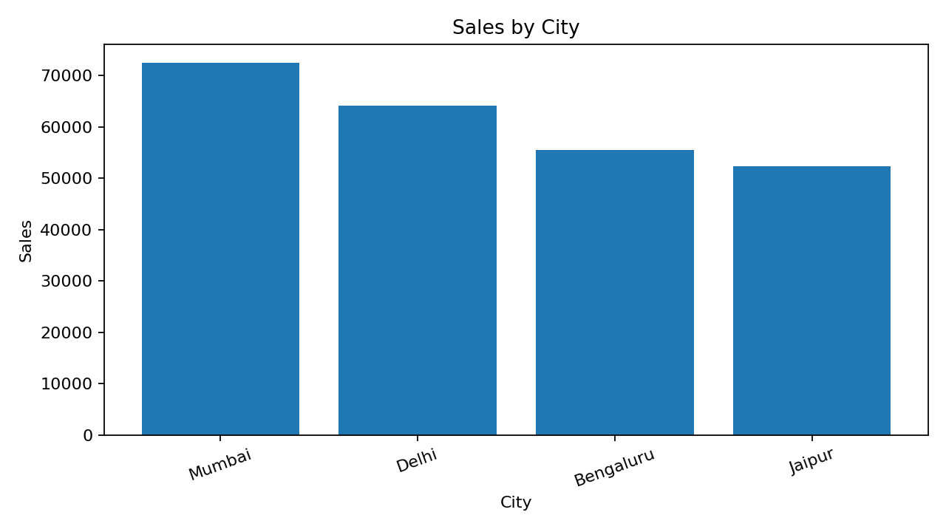

8. Category and Product Analysis
Beverages is the highest-sales category (56,108.24). Cheese is the highest-sales product (27,906.30).
Category | Sales | Quantity | Transactions
Beverages | 56,108.24 | 465 | 82
Personal Care | 45,943.96 | 399 | 73
Dairy | 43,992.00 | 345 | 68
Grocery | 40,470.47 | 439 | 82
Fruits | 23,263.17 | 223 | 44
Snacks | 16,992.97 | 443 | 75
Vegetables | 11,124.17 | 290 | 48
Bakery | 6,516.10 | 164 | 28
Top 10 products by sales:
Product | Sales | Quantity | Transactions
Cheese | 27,906.30 | 126 | 26
Coffee | 27,694.87 | 153 | 24
Shampoo | 27,497.48 | 152 | 27
Cooking Oil | 21,525.06 | 142 | 26
Tea | 17,681.59 | 146 | 29
Apples | 17,057.41 | 119 | 20
Face Wash | 11,946.85 | 100 | 19
Rice | 11,754.17 | 167 | 29
Cold Drink | 10,731.78 | 166 | 29
Eggs | 10,429.77 | 117 | 20
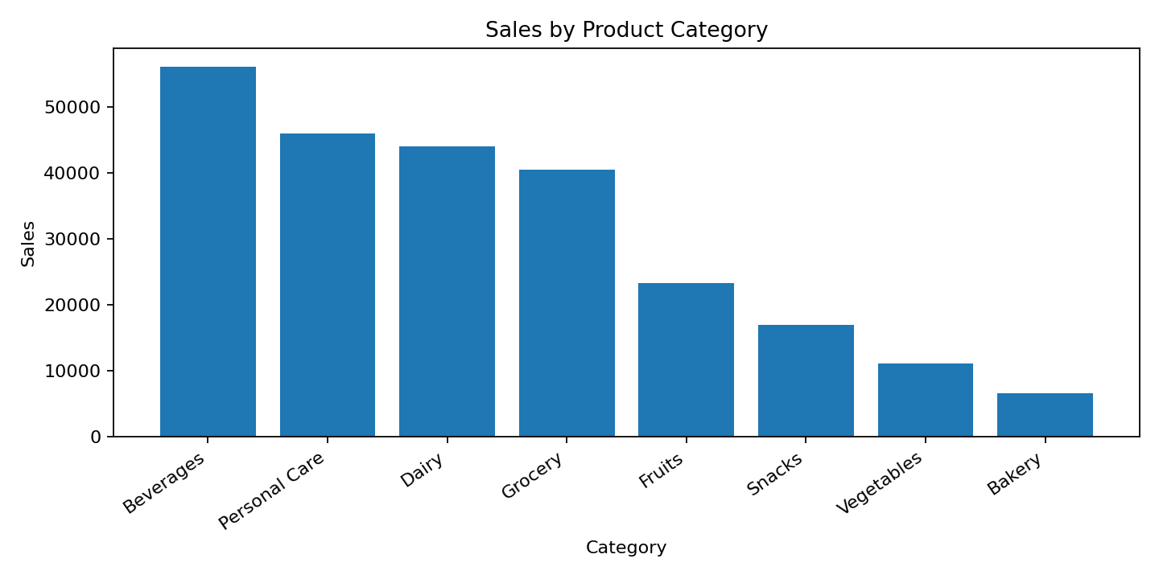

9. Monthly Sales Trend
2026-04 has the highest recorded monthly sales (52,569.77).
Month | Sales | Quantity | Transactions
2026-01 | 43,415.53 | 456 | 88
2026-02 | 30,068.15 | 376 | 65
2026-03 | 37,306.42 | 467 | 83
2026-04 | 52,569.77 | 527 | 90
2026-05 | 42,542.31 | 483 | 85
2026-06 | 35,041.46 | 415 | 82
2026-07 | 3,467.44 | 44 | 7
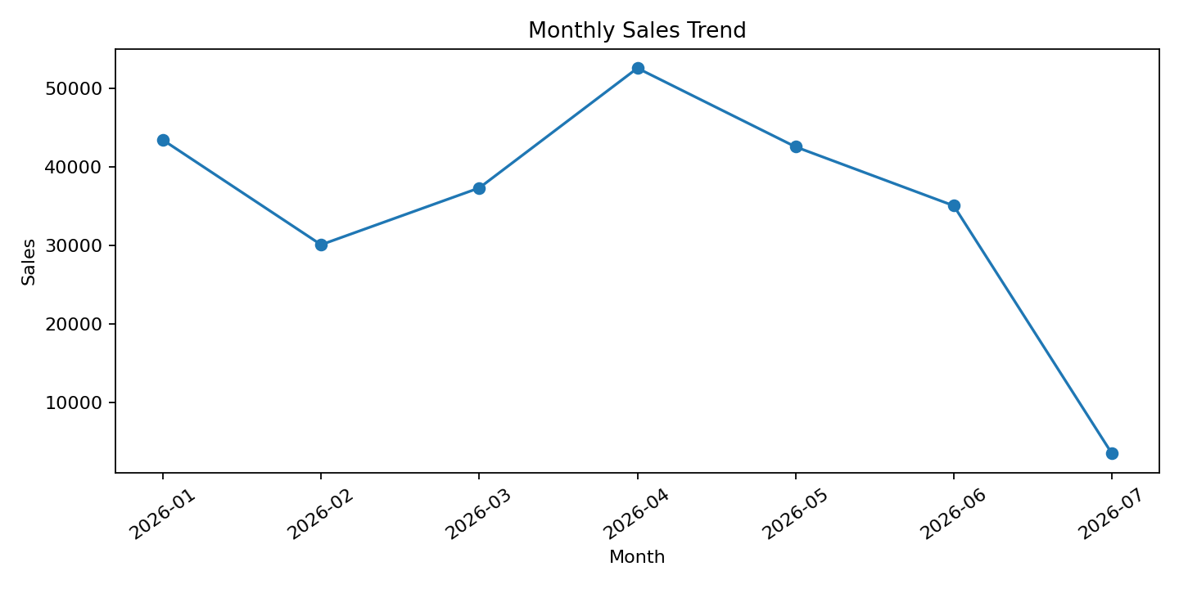
Important limitation: July 2026 contains only 7 transactions dated July 1, so July is a partial month and should not be treated as a complete-month comparison.

10. Payment Method Analysis
Payment | Sales | Transactions
UPI | 67,910.33 | 127
Net Banking | 65,194.93 | 126
Card | 57,265.64 | 125
Cash | 54,040.18 | 122

11. Customer Analysis
Customer Type | Sales | Transactions | Avg_Rating
Member | 143,009.30 | 296 | 4.01
Normal | 101,401.78 | 204 | 3.97
The notebook also includes gender-level sales, transaction count and average-rating analysis.

12. Business Insights
- Total recorded sales are 244,411.08 from 500 unique transactions.
- Mumbai has the highest city-level sales (72,469.45).
- Beverages has the highest category-level sales (56,108.24).
- Cheese has the highest product-level sales (27,906.30).
- 2026-04 has the highest recorded monthly sales (52,569.77); July is partial.
- The average customer rating is 3.99/5.

13. Technologies Used
- Python 3
- Pandas
- NumPy
- Matplotlib
- OpenPyXL
- Jupyter Notebook

14. AI / Future Analytics Extension
The project provides a clean analytical base for future AI/ML work such as demand forecasting, customer segmentation, anomaly detection and natural-language reporting. A larger historical dataset should be used before predictive modeling.

15. Conclusion
This project demonstrates an end-to-end data analytics workflow from raw Excel data to validated KPIs, visual analysis and documented business insights. The notebook is reproducible and the README and requirements file provide the setup information required to rerun the analysis.

16. Reproducibility / Run Instructions
- Keep SUPER MARKET DATA(3).xlsx in the same folder as the notebook.
- Install the libraries in requirements.txt.
- Launch Jupyter Notebook.
- Open GulamMahiuddin_SupermarketSalesAnalysis.ipynb.
- Run all cells from top to bottom.
End of Project Report

